
Foundation University Islamabad
School of Science and Technology

Name: Hunaina Yasir Roll Number: 073
Subject: Oops Lab Section: B
LAB REPORT NO.2
Exercises: LAB 02
TASK 1:
Write a class Student with three data members: RollNo, Name, and Marks. The class should have:
i. A default constructor to initialize values to 0 or empty.
ii. A parameterized constructor to initialize values using arguments.
iii. A display() function to print the details.
iv. In main(), create two objects: one with default values and another with provided values.
SOURCE CODE:
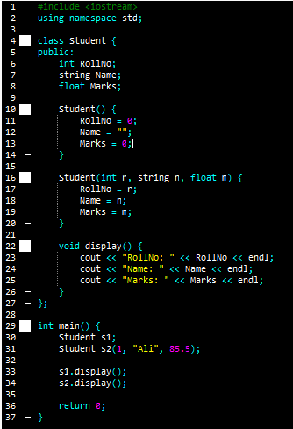
#include <iostream>
using namespace std;

class Student {
public:
int RollNo;
string Name;
float Marks;

Student() {
RollNo = 0;
Name = "";
Marks = 0;
}

Student(int r, string n, float m) {
RollNo = r;
Name = n;
Marks = m;
}

void display() {
cout << "RollNo: " << RollNo << endl;
cout << "Name: " << Name << endl;
cout << "Marks: " << Marks << endl;
}
};

int main() {
Student s1;
Student s2(1, "Ali", 85.5);

s1.display();
s2.display();

return 0;
}

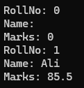
OUTPUT:
RollNo: 0
Name:
Marks: 0
RollNo: 1
Name: Ali
Marks: 85.5

TASK 2:
Write a class Rectangle with two private data members: length and width. The class should have:
i. A parameterized constructor to initialize values.
ii. A copy constructor that initializes a new object with values from another object.
iii. An area() function to return the area.
iv. In main(), create an object and then create a second object using the copy constructor, displaying both areas.
SOURCE CODE:
#include <iostream>
using namespace std;

class Rectangle {
private:
int length;
int width;

public:
Rectangle(int l, int w) {
length = l;
width = w;
}

Rectangle(const Rectangle &r) {
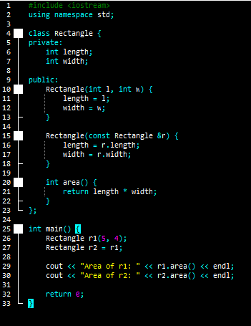
length = r.length;
width = r.width;
}

int area() {
return length * width;
}
};

int main() {
Rectangle r1(5, 4);
Rectangle r2 = r1;

cout << "Area of r1: " << r1.area() << endl;
cout << "Area of r2: " << r2.area() << endl;

return 0;
}

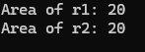
OUTPUT:
Area of r1: 20
Area of r2: 20

TASK 3:
Write a class Car with three private data members: Model, Company, and Price. The class should have: i. A parameterized constructor to initialize values.
ii. A destructor that prints "Object Destroyed" when an object is deleted.
iii. A display() function to print details.
iv. In main(), create two objects and observe when the destructor is called.
SOURCE CODE:
#include <iostream>
using namespace std;

class Car {
private:
string Model;
string Company;
float Price;

public:
Car(string m, string c, float p) {
Model = m;
Company = c;
Price = p;
}
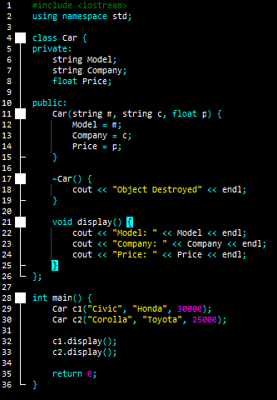
~Car() {
cout << "Object Destroyed" << endl;
}

void display() {
cout << "Model: " << Model << endl;
cout << "Company: " << Company << endl;
cout << "Price: " << Price << endl;
}
};

int main() {
Car c1("Civic", "Honda", 30000);
Car c2("Corolla", "Toyota", 25000);

c1.display();
c2.display();

return 0;
}

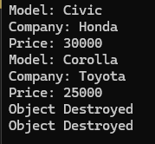
OUTPUT:
Model: Civic
Company: Honda
Price: 30000
Model: Corolla
Company: Toyota
Price: 25000
Object Destroyed
Object Destroyed

TASK 4:
Write a class Circle with one private data member: radius. The class should have:
i. A default constructor that initializes radius = 1.
ii. A parameterized constructor that sets radius based on an argument.
iii. A circumference() function that returns the circumference.
iv. In main(), create two objects using both constructors and display their circumferences.
SOURCE CODE:
#include <iostream>
using namespace std;

class Circle {
private:
double radius;

public:
Circle() {
radius = 1;
}

Circle(double r) {
radius = r;
}

double circumference() {
return 2 * 3.14 * radius;
}
};

int main() {
Circle c1;
Circle c2(5);

cout << "Circumference of c1: " << c1.circumference() << endl;
cout << "Circumference of c2: " << c2.circumference() << endl;

return 0;
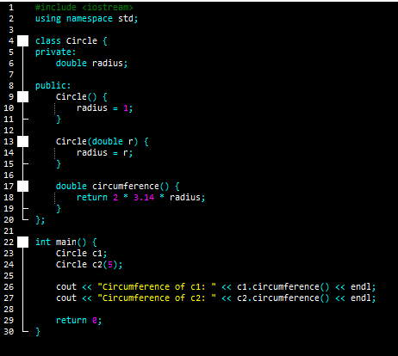
}

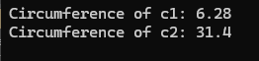
OUTPUT:
Circumference of c1: 6.28
Circumference of c2: 31.4

TASK 5:
Write a class Resource with a private data member value. The class should have:
i. A parameterized constructor to initialize value.
ii. A move constructor to transfer ownership.
iii. A display() function to print the value.
iv. In main(), create an object and then use move() to initialize another object, displaying both values.
SOURCE CODE:
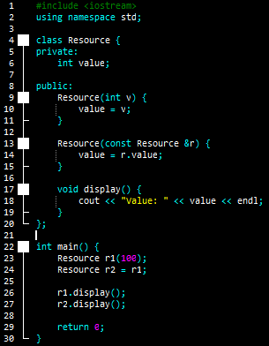
#include <iostream>
using namespace std;

class Resource {
private:
int value;

public:
Resource(int v) {
value = v;
}

Resource(const Resource &r) {
value = r.value;
}

void display() {
cout << "Value: " << value << endl;
}
};
int main() {
Resource r1(100);
Resource r2 = r1;

r1.display();
r2.display();

return 0;
}

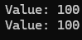
OUTPUT:
Value: 100
Value: 100

